Index No. _________

MILITARY COLLEGE OF SIGNALS
Mid Term Examination – Engineering Mathematics
(BESE – 16)

Instructor: Dr Saeed Murtaza Date: April 04, 2011
Max Time: 90 min Max Marks: 30

Note
- Attempt all questions in the given sequence.
- Understanding question is the part of examination.
- Show complete working, i.e., do not miss any point in your solution and do not leave any thing for the instructor to assume on your behalf.
- There are no marks for the procedure only.
- Programmable calculators are not allowed.
- Attach question paper with the answer sheet.

Q. No. 1:
- What is the origin of differential equations? Give one example.
- What is the difference between particular solution and singular solution?
- Write down the characteristics of a “Linear Ordinary Differential Equation”.
[2+1+1+2]
Q. No. 2:
While discussing the method of solving a “Separable Differential Equation”, the instructor described following:
“An ordinary differential equation, which can be written like 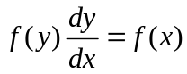 is known as Separable Differential Equation and it can be solved using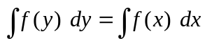”.

A critical student from the class objected that “this not correct because left hand side is being integrated w.r.t. y and the right hand side is being integrated w.r.t x. This is a violation of mathematical rules. Both sides should be integrated w.r.t. the same variable”.

If you were the instructor how will you justify your statement?
[2]

Please Turn Over
Q. No. 3:
Some biologists are doing research on an ant population. They mark out a 2-metere by 2-meter square. They don’t control the migration of ants in or out of the square. Suppose that there is a net emigration of ants out of the square with a rate “a” ants per day. Suppose ants reproduce according to natural growth, at “k” new ants per ant per day.
- Develop a mathematical model.
- Find the general solution
- Verify that the proposed solution is the right answer.
[4+2+1]
Q. No. 4:
We can calculate an “Integrating Factor” by using either 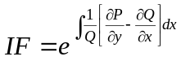or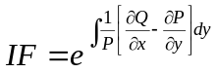. It is a rule that we must add a constant of integration just after the integration. Explain why there is no need to write a constant of integration with the Integrating Factor?
[2]
Q. No. 5:
Solve
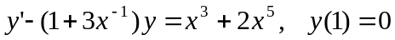
[4]
Q. No. 6:
Solve
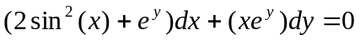
[3]
Q. No. 7:
- What made us guess that the solution of Euler-Cauchy equation 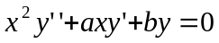could be 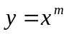
- Solve
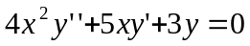
[2+4]

